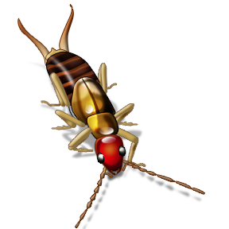
Earwigs

¹Believe it or not, earwigs make very good mothers. ²The mother stays with her eggs. ³She cleans them and keeps them safe. ⁴Many insects just lay their eggs and leave. ⁵The mother earwig helps the babies hatch out of their eggs. ⁶Once they have hatched, she helps them eat. ⁷She also keeps them out of danger.

