A Brief History of America’s Independence Part 1: <http://youtu.be/tfnrdWYmZus>

Show this video a couple of times. It is only 2:47. A note taking guide has been provided as well as a transcript of the narration. The note taking guide can be pasted into an interactive notebook.

Viewing Number 1: The first time just have students get their bearings with the information.

Viewing Number 2: Have students record notes for each of the key events on the note taking guide. Clarify key vocabulary such as: treaty, debt, taxes

Viewing Number 3: Have students look for the causes and effects between each of these events, drawing a line between boxes as they begin to see connections.

Some possible Causes and Effects students might see:

* Because of the argument regarding territory the French and Indian War started.
* Because a tremendous debt had been incurred the British taxed the colonists to pay for the debt.
* Because the colonists had no say in the taxation they became angry, refused to pay, and tossed the tea in the harbor.
* Because the colonists were not obeying the British became angry and sent troops.

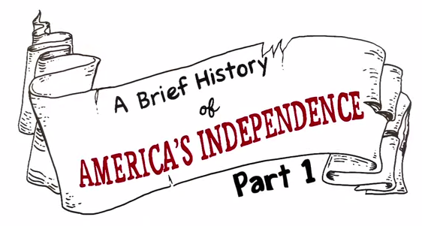

|  |  |  |
| --- | --- | --- |
| Date | Event | Notes |
| 1607 | C:\Users\jireland\Pictures\Brief history rev2.png |  |
| 1754 | C:\Users\jireland\Pictures\Briefy history rev 3.png |  |
| 1756-1763 | C:\Users\jireland\Pictures\Brief History 4.png |  |
| 1765 | C:\Users\jireland\Pictures\Brief History rev 6.png  C:\Users\jireland\Pictures\brief history rev 7.png |  |
|  |

|  |  |  |
| --- | --- | --- |
| 1773 | C:\Users\jireland\Pictures\Brief history rev 8.png |  |
| 1775 | C:\Users\jireland\Pictures\Brief history rev 9.png |  |

**Published on Nov 5, 2013**

We created this video to help explain the events in American History leading up to the Revolutionary War... To be continued!   
  
For more information, visit 321learning.com  
  
Transcript:

It all started back in 1607 with the first successful English settlement, Jamestown Virginia... soon followed by Plymouth Massachusetts.

Over the next 130 years, cities developed and in 1754, the entire East Coast was established as thirteen British colonies. The British were not the only ones establishing colonies... the French were starting their own colonies in the area now known as Canada.

Then the French and British started getting into arguments over territory...and then from 1756 to 1763 the French and the Indians fought against the British and the colonists and the French and Indian War also known as the Seven Years War. The colonists and the British won the war.

To make it official, the British and the French signed the Treaty of Paris in 1763. Not only did the treaty end the war, but also granted the British controlled the territory from the Mississippi River to the Appalachian Mountains.

But the war left the British with a bunch of debt so they taxed the American colonists A LOT and then in 1765 they passed the Stamp Act and all important papers and documents needed to be produced in Great Britain and have a special stamp and the American colonists had to pay for this too. Even with new territory colonists were very angry that the British were robbing them of their hard-earned things by making them pay unreasonable taxes on things like tea and postage and there was nothing they could do about it because they didn't even have any representation in the British Parliament.

They had had enough. So they decided to stop paying taxes completely....But they were just getting started. In 1773, three British ships delivering tea from the East India Tea Company were ambushed by colonists disguised as American Indians. They dumped all the tea into the harbor. This act of aggression went down in history as the Boston Tea Party.

The British were steamed and started assembling troops to move against the American colonists.  
Paul Revere, a silversmith from Boston received this top secret information and jumped on his horse...  
warning... "The British are coming, the British are coming!" The next morning on April, 19, 1775 the first attacks from the colonists against the British happened in Lexington, Massachusetts with the "shot heard round the world." This marked the start of the American Revolutionary War. To be continued...