PUSD
Opinion
Writing Prompt, Rubric, and Resources
Grade 2
2014-2015
Opinion Writing
Formative Assessment (Teacher Provides) Administration Dates: Oct. 13-17, 2014
Summative Assessment (District Provided) Administration Dates: December 1-5, 2014
Data due in Illuminate: December 19, 2014
Grade level standard:
{Write opinion pieces on topics of texts, supporting a point of view with reasons and information.
- Introduce a topic or book clearly, state an opinion, and create an organizational structure in which ideas are logically grouped to support the writer’s purpose
- Supply reasons that support an opinion.
- Use linking words to connect the opinion and reasons
- Provide a concluding statement or section related to the opinion presented.}

General Information About Writing Assessments
- Schedule uninterrupted time blocks in the morning when students are most fresh.
- Refer to the script provided with your assessment so that administration can be as uniform as is reasonably possible between rooms.
- Student assessment materials are limited to what is provided in their packets.
Students may have:
  - Red/blue pens
  - Access to dictionary/thesaurus
  - As much blank/lined paper as needed
  - Walls do not need to be covered up for this assessment.

- Students will not receive a graphic organizer. They will need to create one on their own.
- Do not run off other materials for your students.
  - No templates
  - No lists
  - No graphic organizers
- A rubric for assessing student work has been provided for you. If you need more, please run them off.
Student Writing Assessment
Prompt for Opinion Writing
Common Core Standard W2.1 Write opinion pieces in which they introduce the topic or book they are writing about, state an opinion, supply reasons that support the opinion, use linking words to connect opinion and reasons and provide a concluding statement or section.

(Directions should be read aloud and clarified by the teacher.)
Name: ________________________
Before you begin: On a piece of lined paper, write your name and the date. You will use this paper for writing.
(Teacher Briefly Introduces the Topic)
Your teacher is going to read _____________ aloud. As you listen to the text, think about Question: _______________? After you have had a chance to hear the article(s) a second time, you will write an paragraph that states your opinion and explains your thinking.

PROMPT: For the opinion writing, your focusing question will be:
_____________?
You will explain your thinking with facts and reasons from the text(s).
Remember, a good opinion writing will:
- Introduce the topic you are writing about
- Clearly answer the question with your opinion
- Give lots of reasons and explanations
- Wrap up the piece with a concluding sentence
- Use capitals, periods and question marks, and spell words correctly.

You will have two class periods to complete this reading/thinking/writing task. You may take notes right on the articles or on a separate sheet of paper. You may want to take some time to plan your writing before you begin work. When you have finished, check your paper over and fix any mistakes you see.

GOOD LUCK! WE LOOK FORWARD TO READING YOUR GOOD WORK!
Teacher Directions
Day 1 (45 minutes) Prompt: _____________?
- Give out the prompt.
- Read the prompt aloud together. Use the writing process to analyze the prompt.
- Give each student a copy of (name of article). Explain that they may want to underline or take notes on the article as you read it aloud. Read the article aloud.
- Pose the question, “____________?” Remind students to use the article and their notes when thinking through their response. Have students turn and talk to a partner about this question. Each student should have a chance to share.
- Explain that tomorrow you will be writing about ___________. Collect the article(s) and assignment sheets. (Be sure names are on them.)

Day 2 (45 minutes) Prompt: _____________?
- Return the article(s) and re-read (both) aloud.
- Ask students to think about (both) article(s). Question? Have students turn and talk to a partner about this. Each student should have a chance to share.
- Return the prompt sheet and re-read it aloud.
- Provide lined paper and give students the remainder of the period to write. The writing should be completed individually, without help.
- When the period is over, explain that students may finish writing/revising/editing tomorrow. Collect student work and materials.

Day 3 (45 minutes) Prompt: _____________?
- Return student work and materials. Students may be given access to a dictionary or thesaurus.
- Give students the remainder of the period to finish writing/revising/editing.

* There is no time limit for the writing assessment. A student may take as long as he/she needs to complete the task.

Sample Opinion Writing Prompt
Standard W2.1

Name: ________________________
Before you begin: On a piece of lined paper, write your name and the date. You will use this paper for writing.
Directions: Your teacher is going to read “Should Dogs Work? aloud. As you listen to the text, think about how you feel about this question. Question: Should dogs have jobs or should they just be pets? After you have had a chance to hear the article(s) a second time, you will write a paragraph that states your opinion and explains your thinking.

PROMPT: For this opinion writing, your focusing question will be:
Should dogs have jobs or should they just be pets?
You will explain your thinking with facts and reasons from the text.

Remember, a good opinion will:
- Introduce the topic you are writing about
- Clearly answer the question with your opinion
- Give lots of reasons and explanations
- Wrap up the piece with a concluding sentence
- Use capitals, periods and question marks, and spell words correctly.

You will have two class periods to complete this reading/thinking/writing task. You may take notes right on the articles or on a separate sheet of paper. You may want to take some time to plan your writing before you begin work. When you have finished, check your paper over and fix any mistakes you see.

GOOD LUCK! WE LOOK FORWARD TO READING YOUR GOOD WORK!
Prompt Ideas and Resources
Fiction Opinion Prompt Ideas:
Question:
Which version of Cinderella do you prefer, the traditional or the Chinese version?
Which version of __________ do you prefer and why?
Read Same Story Different Culture- Treasures OR use any two folktales that you are reading for RL 2.9

Question:
“Everybody has their own opinion about the first day of school. Some are excited to come back and some are more nervous.”
What was your opinion of the first day of 2nd grade?
Read David’s New Friends p.10-25 –Treasures AND School is Starting p. 8-9 - Treasures

Question:
Which story did you like better ___________ or ______________?
Which character was your favorite ___________ or ____________?
Read David’s New Friends p. 10 Treasures and Mr. Putter and Tabby Pour the Tea p. 39 Treasures
OR and two stories that you read during this unit

Question:
Which would make a better pet, a cat or a dog?
Read Mr. Putter and Tabby Pour the Tea p.38 Treasures AND “Dog or Cat?” (article attached)

Non-Fiction Opinion Prompt Ideas:
Question:
What kind of person is Condoleezza Rice? How can you tell?
What kind of person is Rosa Parks? How can you tell?
If you could meet and interview Rosa Parks or Condoleezza Rice, who would you choose?
Read “Remembering Rosa Parks” p. 134-135 Wonders AND “One Tough Job” p. 140-141 Wonders

Question:
Which occupation would you prefer?
Read Fighting the Fire p. 236-239 Treasures (firefighters)
A Trip to the Emergency Room p. 82-83 Treasures (admissions worker, nurse, doctor)

Question:
Which invention was most useful and why?
Which inventor would you rather meet?
Read African American Inventors p.287-305 Treasures

Question:
Each of these men made a difference in our world. Who was most important in history, Abraham Lincoln or Dr. Martin Luther King?
Read “Leaders for Freedom” p. 174 – Wonders AND “Dr. King’s Journey” p. 176 – Wonders

Question:
What type of place do we need in our community?
Read and share CA Treasures 2nd Grade ELD Picture Reading cards of community places AND Map Skills - Unit 2 Social Science Then and Now

Question:
Would you rather visit Mount Rushmore, The Lincoln Memorial, or the Grand Canyons? Why?
Read “Monumental Material” p. 68-69 Wonders

Question:
Should dogs have jobs or should they just be pets?
“Should Dogs Work” (article attached)

Question:
Which Earth problem is the most important to solve and why?
Read “A Way to Help the Earth” p. 396-401 – Treasures

Question:
Which would you prefer to grow, food or flowers?
Read “Seed to Fruit” p. 56-57 Wonders AND “Flowers and Fruits” p. 34-41 CA Science

Question:
In your opinion, which resource is the most valuable? Why?
Read Our Natural Resources – Decodable Reader Treasures

Other Prompt Ideas: (Use during Smart Start or Week 1 or as **quick writes)
- Where would you prefer to celebrate your birthday, at a park or at home?
- What is your favorite movie of all times?
- Which book that we have read is the best?
- What is the best TV show for kids?
- Which food do you like better, pizza, or ice cream?
- What is the best type of Halloween candy?
- What is your favorite piece of clothing?
** Yesterday we had a substitute, what was your opinion of how the day went while I was away?
** We just finished reading ___________? Which part was your favorite and why?
** What is your opinion of the activities you did during PE today?
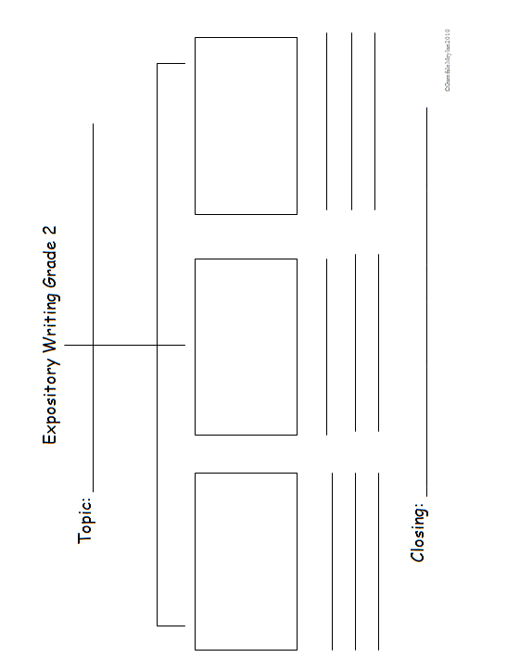

Expository Writing

Second Grade Expository Revising Topics:

____Introduce the topic

____Support the topic with:
___facts/details

____Maintain a focus

____Use linking words and phrases

____Have a concluding sentence

_________ Details to improve the meaning and focus
____add words, phrases, or sentences
____delete/omit words or sentences
____word choice
____word order

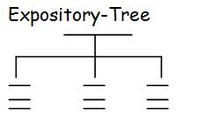

Second Grade Expository Editing Topics:

_________Capitalization
____Beginning of a Sentence
____Proper nouns (names of people, places,things)

_________Punctuation
____Correct end mark at the end of a sentence
____Commas in dates
____Commas in a series

__________Complete/Incomplete Sentences

_________Spelling
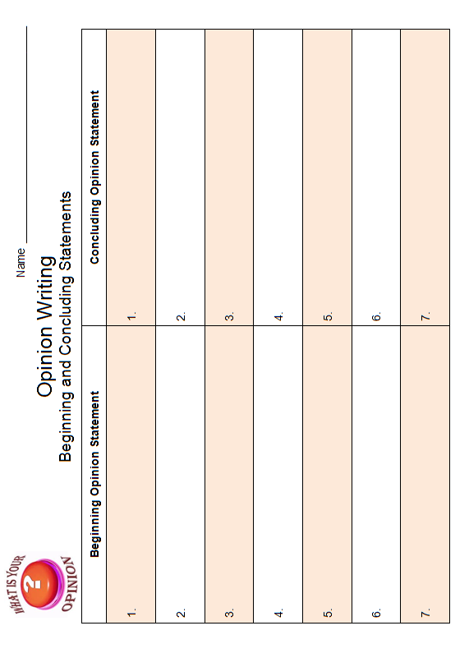
Should Dogs Work?
Many pet dogs spend their days sleeping around the house. They play catch with their owners. And they have all their meals delivered straight to their bowls. Pet dogs give their owners love and friendship. In return, the dogs live carefree lives.
Some dogs don't have it so easy. They are put to work. The dogs are not paid in cash. They are paid in shelter, food, and love. Those are the same things that many pet dogs get. Service dogs give more than pet dogs give. People depend on them for serious work. There are many kinds of service dogs. Some dogs guide people who are deaf or blind. The dogs act as people's eyes and ears.
Other dogs do police work. There are about 15,000 police dogs in the United States. The dogs search for missing people and hunt down criminals. Many dogs are also used to search for drugs and bombs. Service dogs often work long hours. Meanwhile, pet dogs have the freedom to sleep and play whenever they want to. Is it fair that some dogs should have to work? Read the debate. Then decide.
Yes! Dogs Should Work
Service dogs are workers and pets. Usually, they get more attention than pets get. Service dogs often work for their owners. So the dogs spend a lot of time with the people who care for them. Service dogs live happy and useful lives.
Service dogs have to work hard. But they enjoy what they do. Their work can be stressful at times. But the owners make sure that the dogs stay happy. To do that, they give the dogs lots of love and praise for their work. This makes the dogs feel good about the work they do. It makes the dogs want to work more.
Police and service work can be dangerous for dogs. But dogs are brave. They are willing to face danger when they work.
Last year, about 350 dogs worked at the World Trade Center site. One rescue worker said, "If these dogs only knew the difference they make.
Certainly, there's nothing that can replace... a dog's nose. And absolutely nothing that can replace a dog's heart."
No! Dogs Should Not Work
Dogs are meant to be pets. They live short lives compared to humans. They should be allowed to enjoy all of their days. Dogs are meant to be companions, not workers. Service dogs are put under too much stress. Their jobs are not fun. Some service dogs are servants. They do things like opening dresser drawers and pulling their owners' wheelchairs.
Guide dogs for people who are blind and other servant dogs are not put in danger. But police dogs are not as lucky. They face life-and-death situations. People can choose to put their lives on the line. Dogs don't have that choice.
Last year, a police dog was shot and killed by police officers. The dog had caught a person the police were chasing. The police officers didn't realize that the dog was on their side. They thought he was vicious. So they killed him. Weeks before the dog was killed, he had acted as a search-and-rescue dog when the World Trade Center was attacked in New York City.
Dog or Cat?

Should you get that cute little puppy or a cuddly kitten? Deciding between
a cat and a dog can be hard. Here are some things to think about.

Company
Dogs make great listeners. Many people tell dogs things they can't
tell anyone else. Dogs are great for someone who lives alone or
needs company. On the other hand, most cats enjoy being alone.
You can leave them home alone for the day while your family is at
school or work.
Exercise
Cats and dogs both need exercise. Dogs need to be walked every
day. This can be healthy for both of you. Exercise gives you energy.
It also strengthens your muscles and bones. Walking and playing
with your dog can make you both healthier! A cat needs much less
exercise than a dog, but this makes a cat much easier to take care
of. Your cat will probably be happy to chase a ball in your living
room.
Training
Dogs need training to live with people. This can take a lot of time,
but you can teach your dog great tricks. Your dog can learn to sit,
fetch and lie down. Cats need less training. Cats can be trained to
fetch a ball or walk on a leash, but these lessons are just for fun.
You don't need to train your cat to have a good pet.
Both cats and dogs can be wonderful family pets. Which pet is the right one
for you?

Taken from In Common: Achieve the Core

PORT ANGELES SCHOOL BOARD TO BAN CLASSROOM PETS

In Port Angeles, Washington, pets are no longer allowed in school classrooms. There will be no more rabbits, mice, gerbils, or other pets allowed.
The rule change happened because some parents complained that dogs were being brought to school and letting them run in the hallways. Many school board members feel that any animal in the classroom is risky. Children who have asthma or allergies to animals can get sick. Animals can also spread other diseases, such as salmonella, to students.
Parents who want pets to still be allowed in classrooms said that classroom pets give a chance for children who don’t have animals at home to learn the responsibility of caring for pets. Children often take turns bringing the pet home to care for it on weekends. Also, the pets provide a bonding experience for children.

Name__________________________________ Opinion Rubric
Grade 2
 | Content  (Opinion)  SCORE:____________ | Organization  (Revise)  SCORE:____________ | Language  (Edit)  SCORE:____________
4-Grade Level Mastery | * Effectively states a clear opinion.  * Facts and reasons clearly support the stated opinion.  * Completely responds to the prompt. | * Clearly introduces the topic.  * Clearly stays on topic.  * Includes clear, well-chosen words and phrases that improve the meaning and focus.  * Effectively uses linking words and phrases.  * Provides a clear concluding statement. | * Consistently uses pronouns correctly with few errors.  * Consistently uses verb tenses and plural nouns correctly with few errors.  * Consistently produces complete simple and compound sentences correctly with few errors.  * Consistently capitalizes correctly with few errors.  * Consistently punctuates (commas, apostrophes, end punctuation) correctly with few errors.  * Consistently applies spelling rules and patterns (as referenced in the pacing guide) correctly with few errors.
3-Approaching Grade Level Mastery | * States an opinion.  * Facts and reasons mostly support the stated opinion.  * Mainly responds to the prompt. | * Introduces the topic.  * Mostly stays on topic.  * Includes some words and phrases that improve the meaning and focus.  * Uses linking words correctly.  * Provides a concluding statement. | * Consistently uses pronouns correctly with some errors.  * Consistently uses verb tenses and plural nouns correctly with some errors.  *Consistently produces complete simple and compound sentences correctly with some errors.  * Consistently capitalizes correctly with some errors.  * Consistently punctuates (commas, apostrophes, end punctuation) correctly with some errors.  * Consistently applies spelling rules and patterns (as referenced in the pacing guide) correctly with some errors.
2-Making Progress toward Grade Level Mastery | * Opinion is stated but unclear.  * Facts and reasons support the stated opinion.  * Attempts to respond to the prompt. | * Attempts to introduce the topic, but is unclear.  *Somewhat stays on topic.  * Includes few words and phrases that improve the meaning and focus.  * Inconsistently uses linking words correctly.  * Provides an unclear concluding statement. | * Uses pronouns inconsistently with many errors.  * Uses verb tenses and plural nouns inconsistently with many errors.  * Produces complete simple and compound sentences inconsistently with many errors.  * Capitalizes inconsistently with many errors.  * Punctuates (commas, apostrophes, end punctuation) inconsistently with many errors.  * Applies spelling rules and patterns (as referenced in the pacing guide) inconsistently with many errors.
1-Insufficient Progress toward Grade Level Mastery | * Does not state an opinion.  * Facts and reasons do not support the stated opinion.  * Does not respond to the prompt. | * Does not introduce the topic.  * Does not stay on topic.  * Does not include words or phrases that improve the meaning and focus.  * Does not use linking words.  * Does not provide a concluding statement. | * Does not use pronouns correctly.  * Does not use verb tenses and plural nouns correctly.  * Does not produce complete sentences.  * Does not capitalize correctly.  * Does not punctuate (commas, apostrophes, end punctuation) correctly.  * Applies spelling rules and patterns (as referenced in the pacing guide) inconsistently with excessive errors.

Name__________________________________ Opinion Rubric
Grade 2
 | Content  (Opinion)  SCORE:____________ | Organization  (Revise)  SCORE:____________ | Language  (Edit)  SCORE:____________
4-Grade Level Mastery | * Effectively states a clear opinion.  * Facts and reasons clearly support the stated opinion.  * Completely responds to the prompt. | * Clearly introduces the topic.  * Clearly stays on topic.  * Includes clear, well-chosen words and phrases that improve the meaning and focus.  * Effectively uses linking words and phrases.  * Provides a clear concluding statement. | * Consistently uses pronouns correctly with few errors.  * Consistently uses verb tenses and plural nouns correctly with few errors.  * Consistently produces complete simple and compound sentences correctly with few errors.  * Consistently capitalizes correctly with few errors.  * Consistently punctuates (commas, apostrophes, end punctuation) correctly with few errors.  * Consistently applies spelling rules and patterns (as referenced in the pacing guide) correctly with few errors.
3-Approaching Grade Level Mastery | * States an opinion.  * Facts and reasons mostly support the stated opinion.  * Mainly responds to the prompt. | * Introduces the topic.  * Mostly stays on topic.  * Includes some words and phrases that improve the meaning and focus.  * Uses linking words correctly.  * Provides a concluding statement. | * Consistently uses pronouns correctly with some errors.  * Consistently uses verb tenses and plural nouns correctly with some errors.  *Consistently produces complete simple and compound sentences correctly with some errors.  * Consistently capitalizes correctly with some errors.  * Consistently punctuates (commas, apostrophes, end punctuation) correctly with some errors.  * Consistently applies spelling rules and patterns (as referenced in the pacing guide) correctly with some errors.
2-Making Progress toward Grade Level Mastery | * Opinion is stated but unclear.  * Facts and reasons support the stated opinion.  * Attempts to respond to the prompt. | * Attempts to introduce the topic, but is unclear.  *Somewhat stays on topic.  * Includes few words and phrases that improve the meaning and focus.  * Inconsistently uses linking words correctly.  * Provides an unclear concluding statement. | * Uses pronouns inconsistently with many errors.  * Uses verb tenses and plural nouns inconsistently with many errors.  * Produces complete simple and compound sentences inconsistently with many errors.  * Capitalizes inconsistently with many errors.  * Punctuates (commas, apostrophes, end punctuation) inconsistently with many errors.  * Applies spelling rules and patterns (as referenced in the pacing guide) inconsistently with many errors.
1-Insufficient Progress toward Grade Level Mastery | * Does not state an opinion.  * Facts and reasons do not support the stated opinion.  * Does not respond to the prompt. | * Does not introduce the topic.  * Does not stay on topic.  * Does not include words or phrases that improve the meaning and focus.  * Does not use linking words.  * Does not provide a concluding statement | * Does not use pronouns correctly.  * Does not use verb tenses and plural nouns correctly.  * Does not produce complete sentences.  * Does not capitalize correctly.  * Does not punctuate (commas, apostrophes, end punctuation) correctly.  * Applies spelling rules and patterns (as referenced in the pacing guide) inconsistently with excessive errors.

