PUSD
Informative/Explanatory
Writing Prompt, Rubric, and Resources
Grade 2
2014-2015
Informative/Explanatory Writing
Formative Assessment (Teacher Provides) Administration Dates: Feb. 8-12, 2015
Summative Assessment (District Provided) Administration Dates: March 23-27, 2015
Summative data due in Illuminate: April 10, 2015
Grade level standard W2.2:
{Write informative/explanatory pieces on topics of texts, supporting a point of view with reasons and information.
- Introduce a topic and create an organizational structure in which ideas are logically grouped to support the writer’s purpose
- Use facts, definitions, or examples to develop points about the topic.
- Provide a concluding statement or section related to the opinion presented.}

General Information About Writing Assessments
- Schedule uninterrupted time blocks in the morning when students are most fresh.
- Refer to the script provided with your assessment so that administration can be as uniform as is reasonably possible between rooms.
- Student assessment materials are limited to what is provided in their packets.
Students may have:
  - Red/blue pens
  - Post-it notes/highlighters or other active reading tools
  - Access to dictionary/thesaurus
  - As much blank/lined paper as needed
  - Walls do not need to be covered up for this assessment.
- Students will not receive a graphic organizer. They will need to create one on their own.
- Do not run off other materials for your students.
  - No templates
  - No lists
  - No graphic organizers
- A rubric for assessing student work has been provided for you. If you need more, please run them off.
Teacher Directions and Script
Prompt: How does a dragonfly’s body help it survive?
You will explain your thinking with facts, definitions, and examples from the text.

Summary: This task is to be completed in phases over three days. In phase one, students prepare for writing by viewing a video clip (optional), reading source materials, and having class discussions to help students collect facts, definitions and examples to use in their writing. In phase two, teacher reviews the materials and discussions from phase one and allows students to write their piece. In phase three, students are given more time to finish any steps of the writing process that are needed.

Day 1 (Suggested time: 45 minutes)
- Teacher introduces the topic of dragonflies. Teacher says: Today we are going to read to learn facts and details about a dragonfly.

- Optional: Teacher MAY show a video “Dragonfly – National Park animals for Kids” OR “Dragonfly Wings in Slow Motion –Smarter Every Day 91”, nature video about dragonflies. http://youtu.be/A7hjkPknt_M OR http://youtu.be/A7hjkPknt_M

- Give out the student prompt packets and read the prompt together. Use the writing process to analyze the prompt.

- Teacher prepares students for reading. Teacher says: We are going to closely read an article called Dragonflies. As you listen to the text, think about what the author tells us about how a dragonfly’s body helps it survive. After you have had a chance to hear the article a second time, you will write a paragraph that answers the prompt and explains your thinking. You will explain your thinking with facts, definitions, and examples to support your points.

- Have students turn to Dragonflies. Teacher uses close reading strategies with students to draw attention to specific details. Read the articles aloud. Allow students to reread the article or their notes a second time or take more notes as needed as they consider the content.

- Pose the question, How does a dragonfly’s body help it survive? Remind students to use the article and their notes when thinking through their informative piece. Have students share their ideas with each other.

- Teacher MAY collect student ideas on a chart or under doc cam but may not provide his/her own input on the topic. This list of ideas can remain up until the writing process begins. Students should be referring to their own notes and ideas for their writing.

- Explain that tomorrow you will be writing about the prompt. Collect the article(s) and assignment sheets. (Be sure names are on them.)

Day 2 (Suggested time: 45 minutes)
- Return the packets and re-read the article aloud.
- Ask students to think about the article(s). How does a dragonfly’s body help it survive? Have students turn and talk to a partner(s) about this. Each student should have a chance to share their ideas from the previous day. Students may add additional details to their notes.
- Provide lined paper. Teacher says: Write your name and the date at the top. You will use this paper for your writing. Give students the remainder of the period to write. The writing should be completed individually, without help.
- When the period is over, explain that students may finish writing/revising/editing tomorrow. Collect student work and materials.

Day 3 (Suggested time: 45 minutes)
- Return student work and materials. Students may be given access to a dictionary or thesaurus.
- Give students the remainder of the period to finish writing/revising/editing.

* There is no time limit for the writing assessment. A student may take as long as he/she needs to complete the task.

Student Assignment Sheet
Name ___________________________
Prompt: How does a dragonfly’s body help it survive?

Remember, a good informative/explanatory writing will:
- Introduce the topic you are writing about
- Clearly answer the prompt by making points
- Explain with facts, definitions, or examples to support points
- Include a concluding statement.

You will have three class periods to complete this reading/thinking/writing task. You may take notes right on the articles or on a separate sheet of paper. Take some time to prewrite before you begin writing. Plan before you begin writing. When you have finished writing your draft, be sure to check your paper over and fix mistakes you see.

GOOD LUCK! WE LOOK FORWARD TO READING YOUR GOOD WORK!

Prompt Ideas and Resources
Question: (Life Cycles)
Explain how a butterfly grows from egg to adult.
Describe the life cycle of a mammal.
Read “A Butterfly’s Life” p. 42-43 Wonders
Read “Mammals” Chapter 2-Lesson 2 p. 84-91 CA Science
Optional videos: “How does a caterpillar change into a butterfly?” http://youtu.be/5Tvl6wz7e9M OR “Life Cycle of a Butterfly” http://youtu.be/3jl8P0w6X0g

Question:
How does a dragonfly’s body help it survive?
Why is a dragonfly a good predator?
Read “Dragonflies” excerpt “Ancient Insects” (article attached)
Optional videos: Dragonflies – National Park Animals for Kidshttp://youtu.be/A7hjkPknt_M OR Dragonfly Wings in Slow Motion-Smarter Every Day 91 http://youtu.be/oxrLYv0QXa4

Question:
Explain how a plant’s structures help them survive in their different environments.
Read “Plants and Their Parts” p. 26-29 CA Science AND “How Plants Change to Get What They Need” p. 54-56 Wonders
Optional videos: “Learn About Plants – Different Parts” http://youtu.be/CX2m2n2uDAE

Question:
Explain how Save the Elephants Foundation is trying to save elephants.
Read “Follow the Herd” p. 38-39 Wonders

Question:
Explain how natural resources are useful.
Read Our Natural Resources Decodable Reader-Treasures

Question:
How do rocks change? Explain to a classmate how this happens.
Read “Rocks Change” p. 142-145 CA Science AND “The Rock Cycle” (article attached)
Optional videos: Bill Nye the Science Guy & Rocks & Soil http://youtu.be/6Vh1Uwg1ESA

Question:
What is the importance of fossils?
Read “What are Fossils?” p. 84-87 Wonders,
“Super Croc” p. 244-247 Treasures, OR
“Living Fossils” – Leveled readers –Treasures
Optional video: “How are fossils formed?” http://youtu.be/lRwNzsY_A4U

Question:
How can you stay safe around roads? Inform a classmate how to stay safe.
Read Road Safety Leveled Reader-Treasures

Question:
How do the Alvin Ailey Kids work as a team? OR
Describe how the Alvin Ailey Kids prepare for a performance?
Read Dancing as a Team p.326-343 Treasures

Question:
What is friction? How does it affect you?
Read “Changing Motion p. 286-287 CA Science

Other Prompt Ideas: (Use as **quick writes or Week 1)

- What is your bedroom like? Describe your bedroom to someone so they can imagine it as if they have been there.
- How did our class earn their first marble party?
** Explain what you learned during today’s assembly.
** Describe to a new student how they can earn their independent student award.
** Inform another 2nd grade class about the experiment we did and what we discovered.
** Describe our field trip to the ________________.

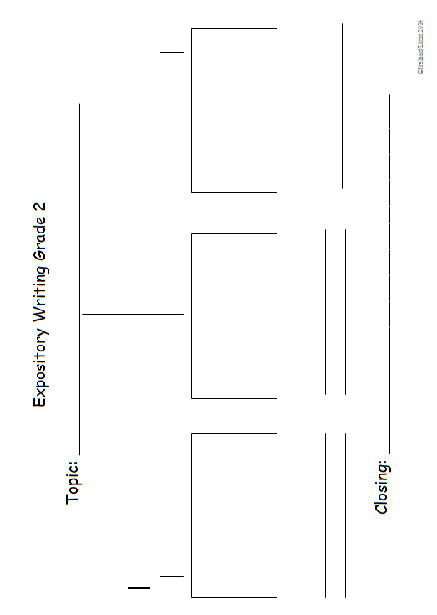

Expository Writing

Second Grade Expository Revising Topics:

____Introduce the topic

____Support the topic with:
___facts/details

____Maintain a focus

____Use linking words and phrases

____Have a concluding sentence

_________ Details to improve the meaning and focus
____add words, phrases, or sentences
____delete/omit words or sentences
____word choice
____word order

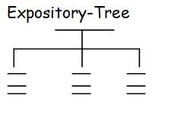

Second Grade Expository Editing Topics:

_________Capitalization
____Beginning of a Sentence
____Proper nouns (names of people, places,things)

_________Punctuation
____Correct end mark at the end of a sentence
____Commas in dates
____Commas in a series

__________Complete/Incomplete Sentences

_________Spelling
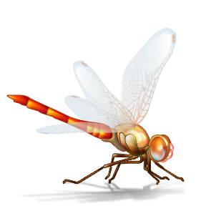 Dragonflies

A green dragonfly lands on a leaf. It waits. Soon a mosquito buzzes by. The dragonfly takes off. It chases the mosquito. It zigs and zags. The mosquito is always on zig or zag ahead of the dragonfly.
Suddenly, the dragonfly speeds up. It catches the mosquito. Then the dragonfly eats the mosquito without even landing.
Flies and mosquitoes better beware! A dragonfly is built to hunt. It’s a predator. That means it’s a carnivore that eats meat.
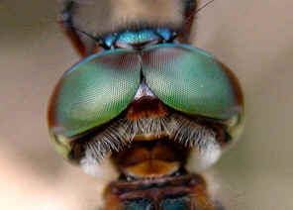
A Dragonfly’s Eyes
A dragonfly’s search for prey begins with its eyes. The head of a dragonfly is almost all eye. It has larger eyes than any other insect.
A dragonfly’s eyes aren’t like yours, though. You have only one lens in each eye. A dragonfly has compound eyes. All insects do. Each compound eye has lots of lenses. Some dragonflies have as many as 30,000 lenses in each eye.
Having large eyes and many lenses helps a dragonfly see in many directions. It can see things in front of, to the side of, and behind it.

Tracking Prey
A dragonfly’s eyes tell it three important things. They tell the dragonfly how far away the prey is. They also tell how fast and which way the prey is moving.
A dragonfly’s brain tracks all of this. It places images from each lens on a mental grid. A grid is like the lines on graph paper.
When a dragon fly is chasing a mosquito, the dragonfly’s brain puts the mosquito image in one part of the grid. The dragonfly focuses on that part of the grid. It keeps its prey in sight at all times.
Fantastic Fliers
Once a dragonfly spots its prey, the dragonfly has to chase it. The dragonfly must get really close before it’s read to attack its prey. So the dragonfly follows the mosquito very closely. It speeds up when the mosquito speeds up.
A dragonfly can fly in many directions. It can move up, down, forward, back, and side-to-side.
A dragonfly can glide through the air. It can hover like a helicopter. A dragonfly can fly upside down!

Wonderful Wings
Many insects have one pair of wings. Dragonflies have two pair of wings.
Most insects’ wings are attached to their bodies. When their bodies move, the wings flap up and down.
Each wing on a dragonfly attaches to a muscle. This connection lets a dragonfly beat its wings together. Each wing can move by itself, too. This combination lets dragonfly move in many directions.
Using its light but strong wings, a dragonfly can fly higher and faster than most insects. Some dragonflies can fly 48 km (30 miles) per hour.
A Dragonfly’s Legs
A dragonfly uses more than its eyes and wings when hunting. It also uses its legs.
A dragonfly has six legs. In the air, it bends its legs to make a basket. Then it scoops up its prey into the basket. Then it scoops up its prey into the basket. Sharp spines on its legs cut into the insect. This keeps the insect from flying away.
Powerful Predator
When a dragonfly isn’t running from predators, it’s searching for prey. It’s often doing both at the same time.
A dragonfly is like an eating machine, and it’s built to hunt. Its eyes, wings, legs, and jaws make it a powerful predator.

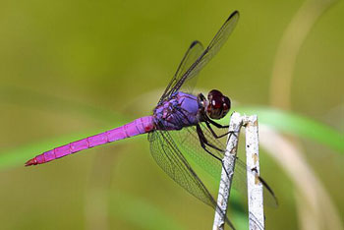

Excerpt from National Geographic Explorer – “Beware of Dragons” March 2014 Pioneer Edition
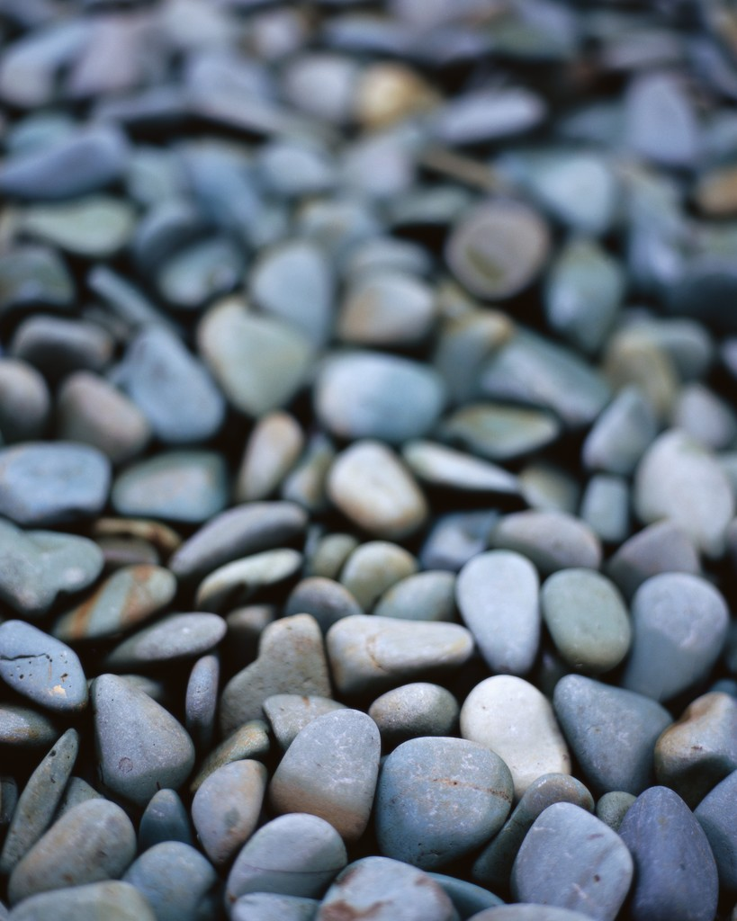
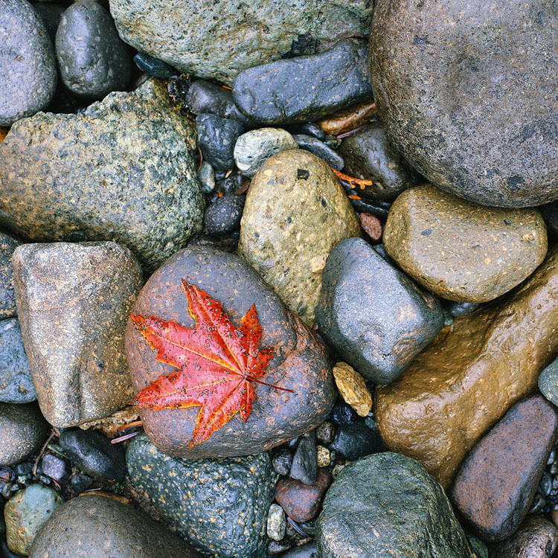
The Rock Cycle
Copyright 2012 K12Reader-http//www.12reader.com
Stand outside and look around you. You will see land. Land is made out of rocks and soil. A lot of rocks are under the soil. Rocks are solid things made out of one or more minerals. Minerals are tiny solids found in nature. They have never been alive.
The rock cycle describes three things. It shows how rocks are formed. It shows how they break apart. Finally, it shows how they are made into other kinds of rocks.
Water, wind, chemicals or growing plants cause weathering. Weathering is the process that makes rocks break into smaller pieces. Water causes most of the weathering of rocks. Many rocks have small cracks that can let in water. The cracks get bigger if the water freezes and then melts again. The cracks finally get so big that the rock breaks into smaller pieces.
Layering is one way new rocks form. Tiny bits of rock and soil build up in layers over long periods of time. The more layers there are, the heavier they are. The top layers push down on the lower layers, and the bits of rock and soil bind together.
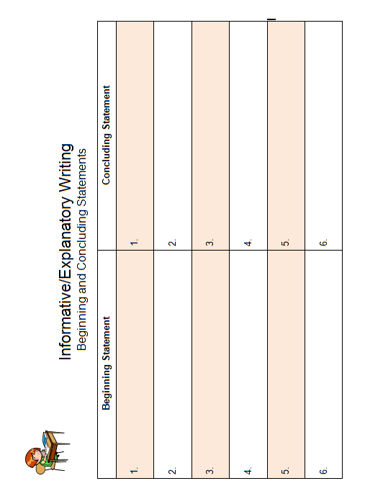
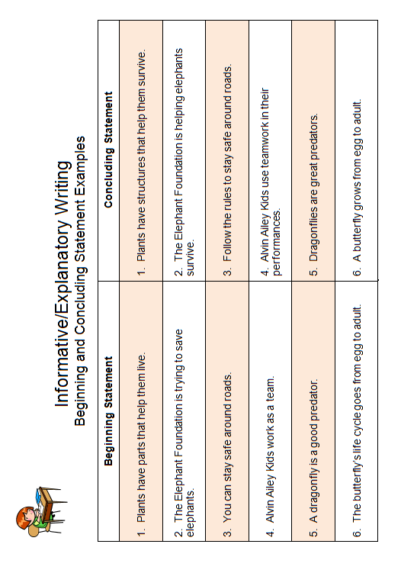

Name__________________________________ Informative Explanatory Rubric
Grade 2
 | Content  (Informative/Explanatory)  SCORE:____________ | Organization  (Revise)  SCORE:____________ | Language  (Edit)  SCORE:____________
4 – Grade Level Mastery | Clearly states multiple points about the topic.  Thoroughly develops the topic by using facts, definitions, and examples to support points on the topic.  Completely responds to the prompt. | * Clearly introduces the topic.  * Clearly stays on topic.  * Includes clear, well-chosen words and phrases that improve the meaning and focus.  * Effectively uses linking words and phrases.  * Provides a clear concluding statement. | * Consistently uses pronouns correctly with few errors.  * Consistently uses verb tenses and plural nouns correctly with few errors.  * Consistently produces complete simple and compound sentences correctly with few errors.  * Consistently capitalizes correctly with few errors.  * Consistently punctuates (commas, apostrophes, end punctuation) correctly with few errors.  * Consistently applies spelling rules and patterns (as referenced in the pacing guide) correctly with few errors.
3 – Approaching Grade Level Mastery | Effectively states at least one point about the topic.  Uses some facts, definitions, and examples to support points on the topic.  Mainly responds to the prompt. | * Introduces the topic.  * Mostly stays on topic.  * Includes some words and phrases that improve the meaning and focus.  * Uses linking words correctly.  * Provides a concluding statement. | * Consistently uses pronouns correctly with some errors.  * Consistently uses verb tenses and plural nouns correctly with some errors.  *Consistently produces complete simple and compound sentences correctly with some errors.  * Consistently capitalizes correctly with some errors.  * Consistently punctuates (commas, apostrophes, end punctuation) correctly with some errors.  * Consistently applies spelling rules and patterns (as referenced in the pacing guide) correctly with some errors.
2-Making Progress toward Grade Level Mastery | Attempts to state at least one point about the topic, but points may not support the topic.  Writing includes few facts, definitions, and examples to support points on the topic.  Attempts to respond to the prompt. | * Attempts to introduce the topic, but is unclear.  *Somewhat stays on topic.  * Includes few words and phrases that improve the meaning and focus.  * Inconsistently uses linking words correctly.  * Provides an unclear concluding statement. | * Uses pronouns inconsistently with many errors.  * Uses verb tenses and plural nouns inconsistently with many errors.  * Produces complete simple and compound sentences inconsistently with many errors.  * Capitalizes inconsistently with many errors.  * Punctuates (commas, apostrophes, end punctuation) inconsistently with many errors.  * Applies spelling rules and patterns (as referenced in the pacing guide) inconsistently with many errors.
1-Insufficient Progress toward Grade Level Mastery | States no points about the topic.  Writing includes no facts, definitions, or examples to support points on the topic.  Does not respond to the prompt. | * Does not introduce the topic.  * Does not stay on topic.  * Does not include words or phrases that improve the meaning and focus.  * Does not use linking words.  * Does not provide a concluding statement. | * Does not use pronouns correctly.  * Does not use verb tenses and plural nouns correctly.  * Does not produce complete sentences.  * Does not capitalize correctly.  * Does not punctuate (commas, apostrophes, end punctuation) correctly.  * Applies spelling rules and patterns (as referenced in the pacing guide) inconsistently with excessive errors.  Licht /Updated 5/20/14

