PUSD
Opinion
Writing Prompt, Rubric, and Resources
Grade 4
2014-2015
Opinion Writing
Formative Assessment (Teacher Provides) Administration Dates: Oct. 13-17, 2014
Summative Assessment (District Provided) Administration Dates: December 1-5, 2014
Summative Data due in Illuminate: December 19, 2014
Grade level standard:
Write opinion pieces on topics of texts, supporting a point of view with reasons and information.
- Introduce a topic or text clearly, state an opinion, and create an organizational structure in which ideas are logically grouped to support the writer’s purpose
- Provide logically ordered reasons that are supported by facts and details.
- Link opinion and reasons using words, phrases, and clauses (i.e. consequently, specifically)
- Provide a concluding statement or section related to the opinion presented.

General Information About Writing Assessments
- Schedule uninterrupted time blocks in the morning when students are most fresh.
- Refer to the script provided with your assessment so that administration can be as uniform as is reasonably possible between rooms.
- Student assessment materials are limited to what is provided in their packets. Students may have:
  - Red/blue pens
  - Access to dictionary/thesaurus
  - As much blank/lined paper as needed
  - Walls do not need to be covered up for this assessment.
- Students will not receive a graphic organizer. They will need to create one on their own.
- Do not run off other materials for your students.
  - No templates
  - No lists
  - No graphic organizers
- A rubric for assessing student work has been provided for you. If you need more, please run them off.
Sample Writing Assessment
Prompt for Opinion Writing
Common Core Standard W4.1

(Directions should be read aloud and clarified by the teacher.)
Name: ________________________
Before you begin: On a piece of lined paper, write your name and grade, the date, and your teacher’s name. You will use this paper for writing.
(Teacher Briefly Introduces the Topic)

Your teacher is going to read _____________ aloud. As you listen to the text, think about ____________. Prompt: _______________? After you have had a chance to hear the article(s) a second time, you will write an essay that states your opinion and explains your thinking.
For the essay, your prompt will be:
Prompt: _____________?
You will explain your thinking with facts and reasons from the article(s).
Remember, a good opinion essay:
- Has an introduction
- Clearly states your opinion/claim in a focus statement
- Uses specific evidence from the text(s) to support your opinion and explains your thinking
- Groups ideas in paragraphs
- Has a conclusion
- Uses precise language and linking words to connect ideas
- Has correct spelling, capitalization, and punctuation

You will have three class periods to complete this reading/thinking/writing task. You may take notes right on the articles or on a separate sheet of paper. Take some time to prewrite before you begin writing. Plan before you begin writing. The essay will have a single draft. When you have finished, be sure to proofread your work.
GOOD LUCK! WE LOOK FORWARD TO READING YOUR GOOD WORK!
Teacher Directions
Prompt: _____________?
Day 1 (45 minutes)*
- Give out the assignment sheet.
- Read the assignment sheet aloud together and use the writing process to analyze the prompt.
- Give each student a copy of name of article. Explain that they may want to underline or take notes on the article as you read it aloud. Read the article aloud.
- Pose the question, “____________?” Remind students to use the article and their notes when thinking through their response. Have students turn and talk to a partner about this question. Each partner needs to take a turn.
- Give each student a copy of name of article. Remind students that they may want to underline or take notes on the article. Read the article aloud.
- Pose the question, “____________?” Remind students to use the article and their notes when thinking through their response. Have students turn and talk to a partner about this question. Each partner needs to take a turn.
- Explain that tomorrow you will be writing about ___________. Collect the article(s) and assignment sheets. (Be sure names are on them.)

Prompt: ___________?
Day 2 (45 minutes)*
- Return the article(s) and re-read (both) aloud.
- Ask students to think about (both) article(s). Read the prompt again. Have students turn and talk to a partner about this. Each partner needs to take a turn.
- Return the assignment sheet and re-read it aloud.
- Provide lined paper (or a computer if your students are accustomed to composing on a keyboard) and give students the remainder of the period to write. The writing should be completed individually, without help.
- When the period is over, explain that students may finish writing and proofread tomorrow. Collect student work and materials.

Prompt: _____________?
Day 3 (45 minutes)*
- Return student work and materials. Students may be given access to a dictionary and thesaurus.
- Give students the remainder of the period to finish writing and proofreading.

*There is no time limit for this writing assessment. A student may take as long as he/she needs to complete the task.
Name ______________

Title of Article (1)

(Print Article Here)

Cited source:
Name ______________

Title of Article (2)

(Print Article Here)

Cited source:

Teacher Resources
Prompt Ideas and Resources
Fiction Opinion Prompt Ideas

My Diary from Here to There, Treasures, Theme 1, Week 1
- What emotion did Amada demonstrate toward moving to United States?

The Adventures of Ali Baba Bernstein, Treasures, Theme 1, Week 2
- Should David Bernstein have changed his name to Ali Baba Bernstein?

Because of Winn-Dixie, Treasures, Theme 1, Week 5
- Do you believe the story about Miss Franny meeting a bear in the library is true or false?.

Mighty Jackie—Treasures, Theme 2, Week 2
- How did Jackie demonstrate the character trait of determination?

- Should women be allowed to play professional baseball with men? Why or why not? (use attached article “Women and Professional Baseball” for more background information)

Non-Fiction Opinion Prompt Ideas

Wonders, pg. 182-183
- Would you rather start at a new school in 6th grade or remain at the same school through 8th grade?

Science Workbook p. 106-111 or Science Textbook p. 248-254
- Which is more deadly, an earthquake or a tsunami?

Social Studies text, Our California, pg. 37-51
- Did the missions have a positive or negative impact on California? (Read Social Studies, pg. 31-40 for more background information)

Child Labor in the U.S.--Treasures, Theme 1, page 74
- Should child labor be allowed or illegal? (Read attached article “Benefits of Child Labor” for more background information.)

Quick Writes or Types (W 4.10):

The purpose of quick writes/types is to give your students an opportunity to practice the genre of writing without going through the entire 5-step writing process or writing a lengthy essay. You can use these quick write prompts as you are introducing the genre so that students can get familiar with opinion writing, or use them in between the prompts where students are going through the entire 5-step writing process. You can always return to their quick writes to do revising/editing practice, peer editing, or typing practice.

Quick Write/Type Prompts:

- Did you like/dislike the game you played during PE/Music/Science class?

- What is your favorite food?

- Did you like/dislike the book/story, _______, that we read in class?

- What is the better place to go on vacation—the mountains or the beach?

- What is your favorite recess activity?

- What is your favorite subject in school?

Women and Professional Baseball
(Adapted from an article by Nancy Doublin on www.bleacherreport.com)
Many people may wonder why women do not play professional baseball. Actually, there have been some women’s professional baseball teams over the last 100 years, but today women and men still do not play professional baseball together on the same team or league. Should women be allowed to play professional baseball?
It is widely accepted that women are as capable and talented as men. There are several examples of women who have successfully played baseball with men. One example is Alta Weiss, who pitched for various semi-pro teams from 1906 to the mid-1920s, Jackie Mitchell, while playing for the Chattanooga Lookouts of the Southern Association’s Double-A league in 1931, pitched in an exhibition game against the New York Yankees. She struck out Babe Ruth and Lou Gehrig, two of the greatest baseball players to play the game. This is proof that women can and should play professional baseball.
Even though there are a few examples of women playing professional baseball, their physical strength and speed will always been different. Some examples are in the Olympics—men and women race separately because the men’s times are always faster than the women’s. In addition, over the last 100 years, men are throwing and hitting the ball farther than back in the 1930’s when women could throw as far as men. Today, women just cannot compete at the same level with men in baseball.
Traditionally, in America, men have played baseball and women have played softball. There are no leagues or teams for girls to play baseball, only softball. Softball and baseball, although similar, are different games. If girls have not been playing baseball in their teenage years, then they are not ready to play for college or move on to the professional level. So another reason women do not play professional baseball is because they do not have the same opportunities as men to play and get better at the game.
The Benefits of Child Labor
(adapted from www.articletrader.com)

Today child labor has become very common throughout the world, but many people consider it an exploitation of children. However, child labor can also have benefits.
First, when a child works, he learns the value of money. He learns the value of work and what it takes to earn that money. Then the child learns how to be responsible for the money they earn and how to spend it wisely.
Secondly, when children work they also help to support their families. (Parker and Harkin, 2007). Instead of children becoming a burden on their parents, they work with them and share in the success of their families by contributing to the household. In some of the poorest parts of the world, child labor is necessary for survival, especially in the slums of Asia and Africa. If child labor were to become illegal, many of these children would be homeless without parents or adults to supervise them which often will lead to criminal activities just to survive.
Child labor does not necessarily mean children are working in sweatshops. In many countries, family-run businesses, such as restaurants, employ their own children to help out and learn practical skills. It is also common for children to work at jobs such as babysitting, lawn mowing, dog walking or pet sitting. Through these jobs, children learn responsibility and how to manage their money.
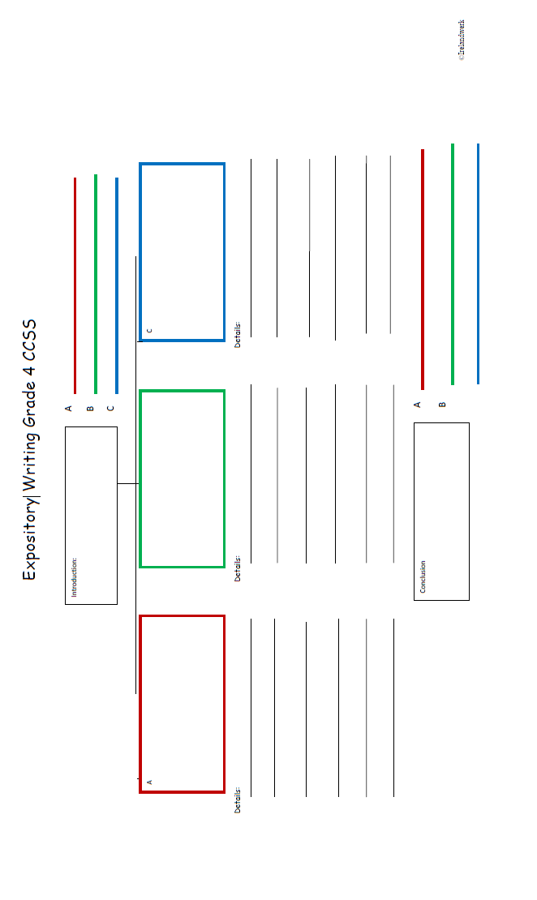
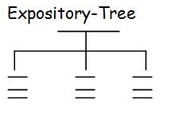
Fourth Grade Revising Topics :

_________Multiple Paragraphs
____Introduction
___introduce a topic
____Develop a Topic with:
___facts/details/examples
___evidence/reasons
___quotations
____ Formatting: headings/illustrations/multimedia
(when useful in informative/explanatory only)
____Concluding statement or section

__________Transitions/ Link ideas using:
___words
___phrases

_________ Details to improve the meaning and focus
____add words, phrases, or sentences
____delete/omit words or sentences
____consolidate or combine short sentences
____word choice (precise or domain-specific language)
____word order

_________Logical/sequential progression of ideas

Fourth Grade Editing Topics:

_________Capitalization
____Titles
____Beginning of a Sentence
____Proper nouns (names of people, places, things)

_________Punctuation
____Correct end mark at the end of a sentence
____Commas in dates, locations, and addresses
____Commas in a series
____Comma before a coordinating conjunction
____Quotations from text—quotation marks and comma

_________Making Sense
____Complete/Incomplete Sentences
____Subject/Verb agreement
____Consistent use of verb tense

________ Grammar (if present then used appropriately)
____ Relative pronouns (who, whose, whom, which, etc.)
____ Progressives (was walking, am walking, etc.)
____ modal auxiliaries (can, may, must, etc.)
____ Order of adjectives (i.e., small red bag)
____ prepositional phrases

_________Spelling (roots, inflections, suffixes, prefixes, and syllable constructions, homophones, frequently misused words)

_________Indent at the start of each new paragraph

Opinion Writing Grade 4
 | Opinion (content)  SCORE:_____________ | Revising Writing (organization)  SCORE:_____________ | Editing Writing (conventions)  SCORE:_____________
4-Grade Level Mastery | Writing introduces the topic/text clearly and states an opinion.  Related ideas are grouped to support the writer’s purpose.  Writing effectively provides reasons supported by facts and details.  Writing completely responds to the prompt.  Writing makes sense. | Always paragraphs appropriately.  Has a topic sentence at the beginning of each paragraph.  Always uses transitional words or phrases to link ideas.  Uses both simple and compound/complex sentences masterfully.  Progression of ideas is logical.  Essay ends with a concluding statement or section that summarizes all the points. | Contains no fragments or run-ons.  Always uses correct subject/verb agreement and consistent verb tense.  Always uses correct grammar.  All punctuation is correct.  All capitalization is correct.  All spelling is correct.  Always indents appropriately.
3-Approaching Grade Level Mastery | Writing introduces the topic/text and states an opinion.  Related ideas are mostly grouped to support the writer’s purpose.  Writing adequately provides reasons supported by facts and details.  Writing mostly responds to the prompt.  Writing mostly makes sense. | Mostly paragraphs appropriately.  Most paragraphs begin with a topic sentence.  Mostly uses transitional words or phrases to link ideas.  Has several compound/complex sentences.  Progression of ideas is mostly logical.  Essay ends with a concluding paragraph that mostly summarizes the points. | Contains few fragments or run-ons.  Mostly uses correct subject/verb agreement and is mostly consistent with verb tense.  Mostly uses correct grammar.  Most punctuation is correct.  Most capitalization is correct.  Most spelling is correct.  Indents appropriately most of the time.
2-Making Progress toward Grade Level Mastery | Writing has a limited introduction of the topic/text and attempts to state an opinion.  Related ideas are loosely grouped to support the writer’s purpose.  Writing seldom provides some reasons supported by few facts and details.  Writing attempts to respond to the prompt, but is mostly about something other than the prompt.  Writing makes some sense, but is unclear. | Seldom paragraphs appropriately.  A few paragraphs begin with a topic sentence  Seldom uses transitional words or phrases to link ideas.  Has a few compound/complex sentences.  Progression of ideas is seldom logical.  Essay may not end with a concluding paragraph that adequately summarizes the main points. | Contains several fragments or run-ons.  Sometimes uses correct subject/verb agreement and is sometimes is consistent with verb tense.  Sometimes uses correct grammar.  Some punctuation is correct.  Some capitalization is correct.  Some spelling is correct.  Seldom indents correctly.
1-Insufficient Progress toward Grade Level Mastery | Writing does not introduce the topic/text clearly or state an opinion.  Related ideas are not grouped to support the writer’s purpose.  Writing does not provide reasons supported by facts and details.  Writing does not respond to the prompt.  Writing does not make sense. | Does not paragraph appropriately.  Does not have a topic sentence at the beginning of each paragraph  Does not use transitional words or phrases to link ideas.  Uses only simple sentences.  Progression of ideas is not logical.  Essay either is missing a concluding paragraph or does not summarize the main points. | Contains mostly fragments or run-ons  Frequent errors in subject/verb agreement and consistent verb tense.  Rarely uses correct grammar.  Frequent errors in punctuation.  Frequent errors in capitalization  Frequent spelling errors.  Does not indent correctly.

