PUSD
Opinion
Writing Prompt, Rubric, and Resources
Grade 5
2014-2015
Opinion Writing
Formative Assessment (Teacher Provides) Administration Dates: Oct. 13-17, 2014
Summative Assessment (District Provided) Administration Dates: December 1-5, 2014
Summative Data due in Illuminate: December 19, 2014

Grade level standard:
Write opinion pieces on topics of texts, supporting a point of view with reasons and information.
- Introduce a topic or text clearly, state an opinion, and create an organizational structure in which ideas are logically grouped to support the writer’s purpose
- Provide logically ordered reasons that are supported by facts and details.
- Link opinion and reasons using words, phrases, and clauses (i.e. consequently, specifically)
- Provide a concluding statement or section related to the opinion presented.

General Information About Writing Assessments
- Schedule uninterrupted time blocks in the morning when students are most fresh.
- Refer to the script provided with your assessment so that administration can be as uniform as is reasonably possible between rooms.
- Student assessment materials are limited to what is provided in their packets. Students may have:
  - Red/blue pens
  - Access to dictionary/thesaurus
  - As much blank/lined paper as needed
  - Walls do not need to be covered up for this assessment.
- Students will not receive a graphic organizer. They will need to create one on their own.
- Do not run off other materials for your students.
  - No templates
  - No lists
  - No graphic organizers
- A rubric for assessing student work has been provided for you. If you need more, please run them off.
Sample Writing Assessment
Prompt for Opinion Writing
Common Core Standard W5.1

(Directions should be read aloud and clarified by the teacher.)
Name: ________________________
Before you begin: On a piece of lined paper, write your name and grade, the date, and your teacher’s name. You will use this paper for writing.
(Teacher Briefly Introduces the Topic)

Your teacher is going to read _____________ aloud. As you listen to the text, think about ____________. Prompt: _______________? After you have had a chance to hear the article(s) a second time, you will write an essay that states your opinion and explains your thinking.
For the essay, your prompt will be:
Prompt: _____________?
You will explain your thinking with facts and reasons from the article(s).
Remember, a good opinion essay:
- Has an introduction
- Clearly states your opinion/claim in a focus statement
- Uses specific evidence from the text(s) to support your opinion and explains your thinking
- Groups ideas in paragraphs
- Has a conclusion
- Uses precise language and linking words to connect ideas
- Has correct spelling, capitalization, and punctuation
You will have two class periods to complete this reading/thinking/writing task. You may take notes right on the articles or on a separate sheet of paper. You may want to take some time to plan your writing before you begin work. The essay will have a single draft. When you have finished, be sure to proofread your work.
GOOD LUCK! WE LOOK FORWARD TO READING YOUR GOOD WORK!
Teacher Directions

Prompt: _____________?
Day 1 (45 minutes)
- Give out the assignment sheet.
- Read the assignment sheet aloud together and use the writing process to analyze the prompt. Give each student a copy of name of article. Explain that they may want to underline or take notes on the article as you read it aloud. Read the article aloud.
- Pose the question, “____________?” Remind students to use the article and their notes when thinking through their response. Have students turn and talk to a partner about this question for 3 minutes.
- Give each student a copy of name of article. Remind students that they may want to underline or take notes on the article. Read the article aloud.
- Pose the question, “____________?” Remind students to use the article and their notes when thinking through their response. Have students turn and talk to a partner about this question for 3 minutes.
- Explain that tomorrow you will be writing about ___________. Collect the article(s) and assignment sheets. (Be sure names are on them.)

Prompt: _____________?
Day 2 (45 minutes)
- Return the article(s) and re-read (both) aloud.
- Ask students to think about (both) article(s). Prompt? Have students turn and talk to a partner about this. Each student should talk for 3 minutes.
- Return the assignment sheet and re-read it aloud.
- Provide lined paper (or a computer if your students are accustomed to composing on a keyboard) and give students the remainder of the period to write. The writing should be completed individually, without help.
- When the period is over, explain that students may finish writing and proofread tomorrow. Collect student work and materials.

Prompt: _____________?
Day 3 (45 minutes)
- Return student work and materials. Students may be given access to a dictionary, thesaurus, spell check, or grammar check.
- Give students the remainder of the period to finish writing and proofreading.

*There is no time limit for this writing assessment. A student may take as long as he/she needs to complete the task.

Teacher Resources
Prompt Ideas and Resources
Fiction Opinion Prompt Ideas
Goin Someplace Special- Treasures
- How did Tricia Ann show courage?
- What character trait did Tricia Ann demonstrate on her way to someplace special?

Sleds on Boston Common-Treasures
- Should the boy have confronted General Gage?

Nights of San Juan-Treasures
- Should the girls have tricked the grandma to help Jose Manuel?

Henry's Freedom Box-Treasures
- What character trait does the main character demonstrate?
The Golden Mare, the Firebird, and the Magic Ring- Treasures
- Which character is the "hero"?
Non-Fiction Opinion Prompt Ideas
Is the turkey or the eagle a better national symbol?
Are printed books or ebooks better?
Should Californians consider ways in which to conserve water?
Are We Killing the Oceans?-Wonders page 50-51
Should we have a program like “Marathon Kids” here in Pittsburg?
What’s the best way to get fit?
attached articles (Marathon Kids, You Can do It).
Wonders Page 38-39

Which is more dangerous? A tornado or a hurricane?
Science Text pages 268-271
Attached articles (Hurricanes, Tornadoes)

Quick Write Ideas
Lunch Counter Encounter-Treasures
- How would you describe Paul?

The Real Princess
- What lesson does the author want you to learn?

Which of the body systems is most important?

Should pets be allowed at school?

Should you be able to wash your car during a drought?
CONCEPTS OF COMPREHENSION: MAIN IDEA 5t h GRADE UNI T
Reading Passage
Text: Copyright © 2007 Weekly Reader Corporation. All rights reserved.
Weekly Reader is a registered trademark of Weekly Reader Corporation.
Used by permission.
© 2010 Urban Education Exchange. All rights reserved.
Marathon Kids
In Texas, schoolchildren are on the run. They won't stop until they
have covered 26.2 miles. That is the distance of a running race called
the marathon.

The students are not running the distance all at once. Instead, they
are running a quarter mile to a half mile at a time. With six months of
effort, they will reach the 26.2-mile goal and receive medals and Tshirts.
It's part of a new physical fitness program called Marathon Kids. The
program challenges children in kindergarten through grade 5 to run a
marathon one step at a time. Studies show that about 30 percent of
American children and teens are overweight, or obese. Marathon Kids
is designed to get kids in the habit of running at an early age.

At the start of the school year, each runner gets a special kit. It
includes a mileage log to keep track of the distance covered. Each kit
also includes a nutritional log to fill out. The goal is to eat five fruits
and vegetables each day for 26.2 days.
You Can Do It!
By Betsy Dru Tecco

Fitness goals can help you find success.
When you watch skateboarders or snowboarders perform daring jumps and
spins, you might wonder how they became so good. You can bet it took
more than courage. "The kids who do these tricks have strength, stamina,
and excellent balance," says Kathy Kaehler, a fitness trainer who created the
kids' exercise programs Schoolhouse Workout and Fitkids. "They've also
practiced so much that their skills look easy." At one time, those boarders
only dreamed of doing those tricks. But they made it happen.
Any accomplishment takes time and effort—but it starts with setting a goal.
Here's some great advice for tackling even your biggest challenges.

Get Goaling
1. Figure out what your goal is. Setting a goal provides focus so that you
can make a plan and stick to it. Make your goal as specific as possible by
understanding why it's important to you and when you want to accomplish
it. For example, you might say to yourself, "I want to improve my karate
skills so I can earn a new belt by the spring."
"You don't want the goal to be too hard so that you get frustrated and quit,"
says Kaehler. Maybe you want to run the 100-meter dash for your school
track team. Breaking your goal into small steps that are easier to reach can
make the process seem a lot more doable. "Instead of focusing on the end
goal—the race—set up a monthly goal," Kaehler says. Each month, gradually
increase the speed and distance of your runs until you are ready to run a
100-meter dash.

2. Write down your goal and your plan of action. It can help you clarify
what you are doing at each step along the way. For example, list the specific
exercises you will do each day and how you will progress. As you accomplish
each step, check it off your list. If you miss a workout, don't give up. Just
get back on track the next day.

3. Seek support. "Work out with someone," Kaehler recommends. "It's
more fun that way, and you'll be more likely to stick with it."
Non-fiction: You Can Do It!

If staying motivated is a problem, think about how you will feel when you
reach your goal. "See yourself crossing the finish line with a huge smile on
your face," says Therese Pasqualoni, a health expert who has created a
physical fitness program called Strike It Healthy.

4. Remember the small accomplishments you made along the way,
even if you fail to reach your ultimate goal. "It's not about being
perfect," says Pasqualoni. "It's about being healthier."

Pep Talk From Real Achievers
Do you need some motivation? Check out what these kids have to say about
setting and keeping goals.

"Don't give up. You may not see any improvements when you first
start, but they will come if you stick to your goal."
—Michael, 12, Deerfield Beach, Fla. Michael has improved his fitness by
riding his bike and participating in a YMCA exercise class.

"If you're trying to get fit, take it little by little. That may mean five
push-ups and sit-ups twice a day and/or limiting yourself to one
sweet food a day. If you believe, you can achieve."
—Amanda, 12, Montvale, N.J. Amanda reached her goal of running a halfmile in three minutes. She plays many sports and runs regularly.

"Don't expect to be good at something when you first begin it. It
may look easy, but once you try it, it's hard. So keep trying, and
someday you'll be triumphant."
—David, 10, of Marana, Ariz. On his second try, David made the soccer
team. He practices every day, does stretches in the morning, and eats
healthy foods.

Get Goaling
Make a copy of this fitness chart. Use it to help you set a fitness goal and
keep track of your progress. At the end of the month, you will be able to
look back and see how well you have done!
Non-fiction: You Can Do It!
© 2012 ReadWorks®, Inc. All rights reserved.
Article: Copyright © 2009 Weekly Reader Corporation. All rights reserved.
Weekly Reader is a registered trademark of Weekly Reader Corporation.
Used by permission.

Earth Science
Hurricanes

Hurricanes are tropical¹ storms that start in the ocean waters near the equator.² The storm moves its way north where the air is cooler. The wind gets stronger and the rain gets heavier. The “eye of the storm” is located in the center of the storm. It is the storm’s calmest part. There is no rain in the eye and it can spread across 20 miles. The winds around the eye can blow as much as 200 miles per hour. They have the ability to uproot trees from of the ground. They can also blow glass out of windows.

In the United States, summer and early fall are hurricane season. Every new season, tropical storms are labeled. The names follow alphabetical order, and alternate between male and female names. For example, the first hurricane may be Hurricane Andrew, then Barbara, Christopher, Deborah, Ephraim, etc.

Hurricanes can last up to 14 days long. They travel for thousands of miles across the ocean. Most of the time they never reach the coast of the U.S., but when they do hit the coast, conditions become very dangerous. When water levels rise, there can be floods and mudslides.³ Houses close to the shore can be wiped out, and the people who live there can be in grave danger.

Earth Science
Tornadoes

Did you ever see the movie The Wizard of Oz? A tornado¹ sweeps up Dorothy and Toto, sending them to a new world where there are witches and talking lions! That entire story is fiction², but tornadoes are real and they are serious business. In fact, they can be the most dangerous storms of all.

Tornadoes are sometimes referred to as twisters or cyclones³. They are shaped like a cylinder⁴. They are born in thunderclouds. The winds inside a tornado swirl around and around and can be more than 300 miles per hour (mph). The winds are so strong that tornadoes can lift animals, cars, and even houses.

The United States has more tornadoes than any other country in the world. States such as Texas, Oklahoma, Kansas, and Nebraska are hit hard by tornadoes. This part of the country is known as “Tornado Alley.” Tornado season is during the springtime and summer. If the conditions are right, a tornado can happen any time of year.
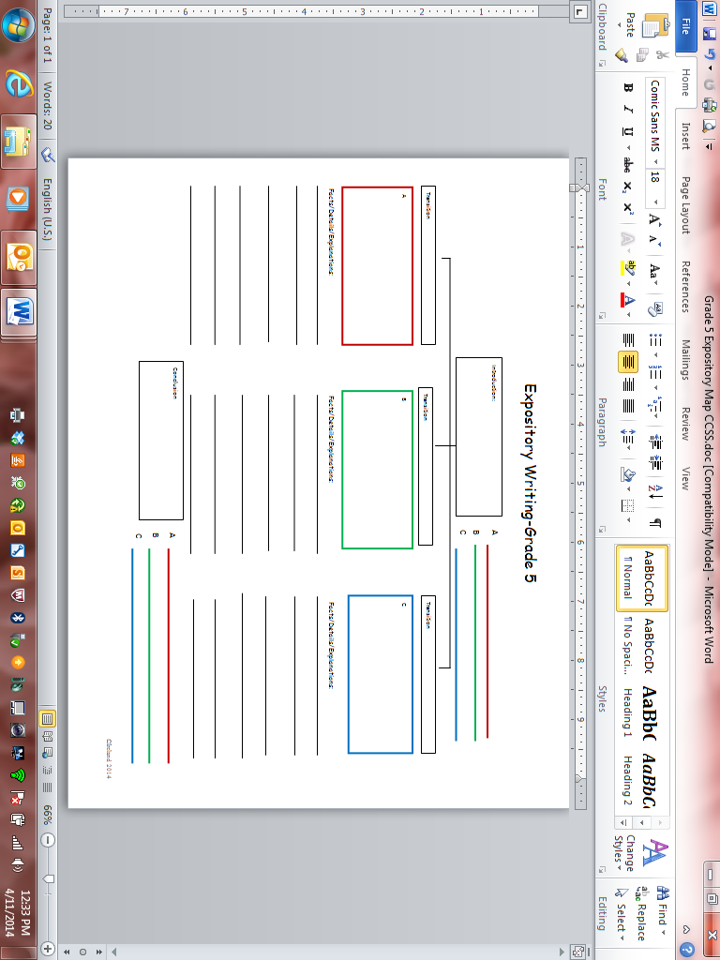
Fifth Grade Revising Topics:
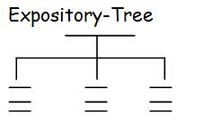
_________Multiple Paragraphs
____Introduction
___establish a topic
____Develop the topic with:
___facts
___evidence
___quotations
____Conclusion

_________Transitions
___within paragraphs
___between paragraphs

_________ Details to improve the meaning and focus
____add words, phrases, or sentences
____delete/omit words or sentences
____consolidate or combine short sentences
____word choice
____word order

_________Logical/sequential progression of ideas as

Fifth Grade Editing Topics:

_________Capitalization
____Titles
____Beginning of a Sentence
____Proper nouns (i.e. names of people, places, things)

_________Punctuation
____Correct end mark at the end of a sentence
____Commas in dates, locations, and addresses
____Commas in a series
____use comma and quotation marks:
___quotations from a text
____use quotation marks:
___ titles of poems, songs, short stories
____underline titles of books, magazines etc

_________Making Sense
____Complete/Incomplete Sentences
____comma between independent/dependent clauses
____comma before a coordinating conjunction
____Subject/Verb agreement
____correct and consistent use of tense

_________Spelling(roots, prefixes, suffixes, contractions, and syllable constructions)

_________Indent at the start of each new paragraph
Name_____________________________________________________________________
Opinion Writing Rubric Grade 5
 | Opinion  (content)  SCORE:_____________ | Revise  (organization)  SCORE:_____________ | Edit  (conventions)  SCORE:_____________
4-Grade Level Mastery | The writing effectively states an opinion.  The writing effectively supports the position with precise and relevant evidence and examples.  Writing completely responds to prompt. | The writing includes an effective introductory paragraph.  The writing includes an effective variety of sentence structures to improve meaning, focus, interest and style.  The writing effectively includes academic words and phrases relevant to the subject.  The writing includes effective transitional words and expressions.  The writing includes an effective concluding paragraph.  The organizational structure logically and effectively supports the writer’s purpose. | Always uses prepositional phrases, interjections, and conjunctions correctly.  Always uses verb tenses and subject verb agreement correctly.  All sentences are complete.  Always uses punctuation correctly.  Always capitalizes correctly.  Always spells correctly.
3-Approaching Grade Level Mastery | The writing adequately states an opinion.  The writing adequately supports the position with evidence and examples.  Writing mainly responds to prompt. | The writing includes an adequate introductory paragraph.  The writing includes an adequate variety of sentence structures to improve meaning, focus, interest and style.  The writing adequately includes academic words and phrases relevant to the subject.  The writing includes adequate transitional words and expressions.  The writing includes an adequate concluding paragraph.  The organizational structure adequately supports the writer’s purpose. | Mostly uses prepositional phrases, interjections, and conjunctions correctly.  Mostly uses verb tenses and subject verb agreement correctly.  Most sentences are complete.  Mostly uses punctuation correctly.  Mostly capitalizes correctly.  Mostly spells correctly.
2-Making Progress toward Grade Level Mastery | The writing does not state a clear opinion.  The writing has limited evidence to support an opinion.  Writing attempts to respond to the prompt. | The writing includes a limited or incomplete introductory paragraph.  The writing includes a limited variety of sentence structures to improve meaning, focus, interest and style.  The writing includes limited use of academic words and phrases relevant to the subject.  The writing includes limited transitional words and expressions.  The writing includes a limited concluding paragraph.  The organizational structure somewhat supports the writer’s purpose. | Some prepositional phrases, interjections, and conjunctions used correctly.  Some verb tenses and subject verb agreement used correctly.  Some sentences are complete.  Some punctuation used correctly.  Some capitalization correct.  Some spelling correct.
1-Insufficient Progress toward Grade Level Mastery | The writing does not state an opinion.  The writing does not support the opinion.  Writing does not respond to prompt. | The writing does not include an introductory paragraph.  The writing does not include a variety of sentence structures to improve meaning, focus, interest and style.  The writing does not include relevant academic vocabulary.  The writing does not include transitional words and expressions.  The writing does not offer a concluding paragraph.  The organizational structure does not support the writer’s purpose. | Few prepositional phrases, interjections, and conjunctions used correctly.  Few verb tenses and subject verb agreement used correctly.  Few sentences are complete.  Few punctuation used correctly.  Few capitalization correct  Few spelling correctly.

